Alexandra Marques Payton Sonia

The teaching program units are designed in collaboration with local partners to address the particular challenges related to water resources and management in Jordan, Palestine, and Mongolia. (Page 4)

Johnson et al. [14] conducted a study on wastewater management initiatives in rural communities in India, highlighting the lack of educational resources targeting children. Sim- ilarly, Chen et al. [15] examined urban wastewater management projects in China, noting a scarcity of educational tools tailored to the younger population. López et al. [16] investi- gated wastewater treatment and reuse as an educational tool in a peri-urban community in Mexico, emphasizing the need to address this educational gap (Page 2).

Questions

* Do you think this curriculum could potentially work in a JJK school? (Should we look further into it?)
* How can treated wastewater reuse be used as an environmental education tool in public schools?
* How will the program in Morocco differ from how the school system is set up here?
  + Government policies and education system. What kinds of restrictions do we have federally, by state, county, etc.
* And the environment here? Is it different?
* How would we tailor the curriculum to fit this age group (5-11) from the existing age group (14-16)?
* How do you think wastewater treatment education in public schools can benefit the community?
* How can wastewater management be used as an environmental education tool? (Page 2).
* Explain building on roles of wastewater management
* What do you remember learning about water infrastructure when you were in elementary school?
* Think back to your younger self: What would you have liked to learn about, water wise?

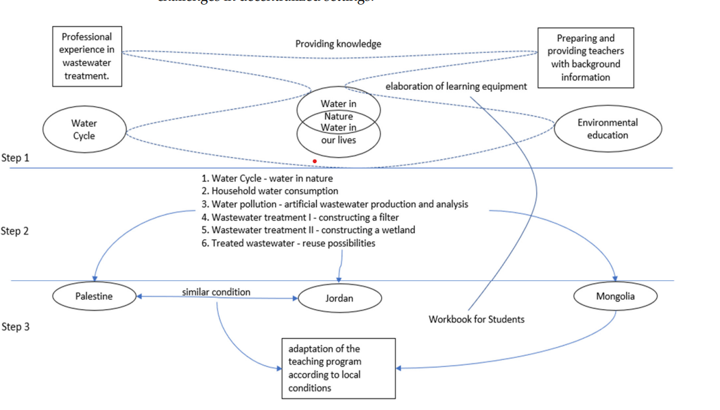

### 

### 

### 

### 

### 

### 

### 

### 

### 

### 

### 

### **Sonia’s Notes :)**

### **The Role of Wastewater Management in Education**

* **Treated wastewater can be reused** for irrigation, industry, and other applications.
* Wastewater management provides a **real-world learning experience** for students, teaching technical, economic, and social aspects of sustainability.
* **Previous research has overlooked** the potential of using wastewater treatment as an educational tool for children.
* **Water scarcity, pollution, and environmental degradation** are global problems, especially in regions like Morocco.
* **Wastewater treatment and reuse** can help address **water shortages** and **sustainability challenges**.
* However, **many schools lack environmental education programs** that teach students about **real-world sustainability solutions**.

Young people **must be educated** on environmental sustainability so they can take action in the future.

Schools can serve as **real-world laboratories** to teach sustainability using hands-on projects like **wastewater treatment gardens**.

**Current wastewater management projects overlook children’s education**, which limits long-term impact.