Ayiana Baynes

Dr. Martinez

CODES 120

16 September 2024

The Quality of Education In Wentzville

In the city where I spent my entire high school career, Wentzville, Missouri, there were several problems that caught my attention. However, the one I am talking about today is the problem in education. During my 4 years at Timberland High School, I suffered immensely both mentally and academically. The education system failed me while I was in person and virtual; leading me to find different ways to get through my time there. Therefore, I would like to shed some light on the issues of this wicked problem.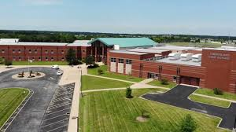

Firstly, I would like to address how the quality of education has the characteristics of a vague problem definition as well as an undefined solution. Simply put, both of these characteristics talk about how different stakeholders have different points of views when it comes to a wicked problem. So, some people could disagree about which is the right solution to the problem, while some people might not even see it as being a problem to begin with. That is why education quality is a wicked problem because there are students who excel to the maximum degree while others fail over and over again under that same curriculum. Additionally, some may see the solution to this problem as needing to spend extra time with the students who are having trouble, but some may see that the best solution is adding in extra time for all students to get more help, regardless of their current performance. In the same sense, some people could think that more money would be a solution to this problem, but others might not.

Secondly, education is a wicked problem because it has the characteristics of having no end point and being irreversible. To further elaborate, the solutions that are implemented in order to resolve this problem will only help for so long. The reason behind this is because not every student is the same; they don't think or act the same. So, not only will the initial solutions not work for some students at that moment, but they might have to be changed when a group of students the complete opposite of their predecessors come through needing help in different ways. Adding on to that, the solutions that are implemented are irreversible because the techniques used to try to help these students will stick with them for a while. If the solutions negatively affect them, they might not show up right away, but they will end up causing some sort of long term consequence. To give an example, let’s look at how there are kids who learn at different speeds, in different ways, etc. So if we implement a solution that only helps the most represented group of students, then the students who have some sort of learning disabilities will be left out and most likely will fall farther behind.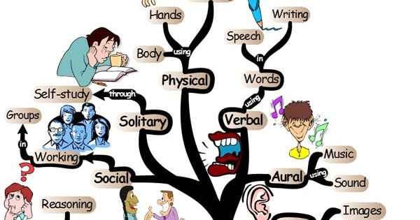

Thirdly, education is a wicked problem because it has the characteristic of being unique. The reason behind this is because every human being is unique in their own way; from the way they think, act, talk, etc., something about them sets them apart from the rest. Therefore, the solutions needed to resolve this problem will need to be unique as well in order to fit the people they are helping. For example, a student could find out that they learn better when they see and hear what they’re learning, so then one of the solutions would need to include something of the sort.

Lastly, education is a wicked problem because it has the characteristic of being urgent. I know from personal experience that the things I went through during high school will forever impact me because I did not receive the help I needed before my self-help tactics became a habit. Going more into it, students who struggle in high school, and do not receive the help they need, either give up or find other ways to “help” themselves. However, in my own experience it does more to hurt in the long run. For example, I have conditioned myself to procrastinate until the last minute because I never learned how to plan and go step by step when doing assignments and projects. I never had the resources, or motivation to obtain those resources, that would help me to become more proactive. Therefore, students need help now because the longer they continue to self-help or just give up, the more long term their damage will be.

In conclusion, education quality is a wicked problem because it has all six of the characteristics of one. There are so many different points of views on how the quality of education is, there will always be a need for a solution because people are always changing since everyone is different in the way they learn, retain information, etc., and lastly, because any solution that is implemented will ultimately become irreversible. Therefore, after having to endure this personally, I strongly advocate for the resolving of this wicked problem.