Reflection #1 Codes 122
Evitt Nashed
Dr. Hildebrandt
February 5, 2024
Indigenous Knowledge in the Herbarium
All of CODES class went to the herbarium to do research on their group projects they did last semester. These groups were to apply their knowledge from their Digital Project to the research we were doing with the archives provided. Kadyance, Kasey, Troy and I had the group of Indigenous knowledge in the Herbarium. We were to apply the knowledge we knew about indigenous knowledge to the archives that were related to it. We had multiple archives provided from the researchers to go with our group. I really had a very fun, informational day at the herbarium! It was very interesting to know the history about some of the plants.
The documents that were provided for us were informative about all the different plant species, the causes, location it was found, the description of the plant, etc. Some things these pressed plants had in common was the description of the plant. They all provided very descriptive information about how tall the plant can be, the color, etc. (insert pic)
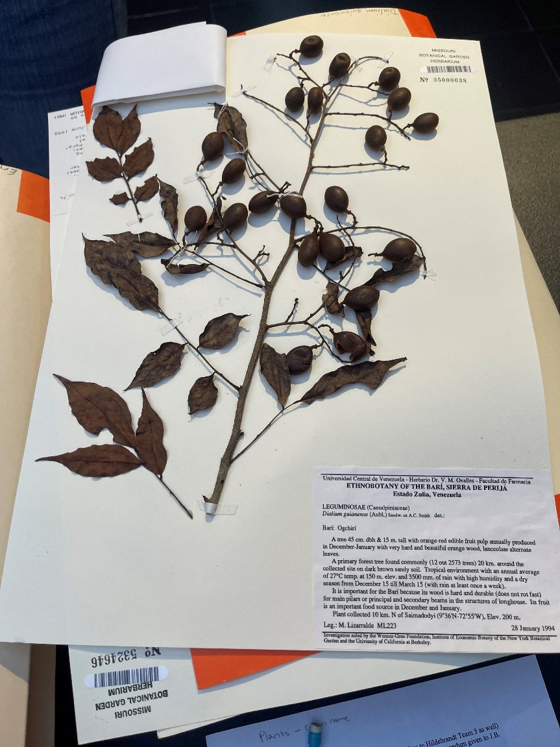
These documents provide such useful information for researchers and botanists, but they also can miss some information that can give us good context of the plant. These botanists go to different countries to explore plants for their job and to give as much information as they can. The botanists are the only ones that are “heard the loudest” because they don’t really include other opinions or how these plants could be used in an indigenous way. Some voices that are silenced would be the indigenous people living in the area these botanists do research at. One researcher from the MOBOT quoted that there is “One voice in a whole country that’s heard.” These botanists only identify in their perspective and not others.
The big question is how can we as CODES research members fill this gap of silence? The main way is we can use these building blocks the botanists provided and conduct an interview with indigenous people and how they use their plants. These indigenous people deserved to be heard in their practices of using plants. It is important to get their perspective on a plant because they can be using it in a more beneficial way these botanists never knew about. There might even be a different name they use to identify these plants.
To end it all, I have learned from this archive trip that botanists can be biased with identifying plants. It is all told in their perspective and not other people. It is important to include the information the indigenous people provide because they can give us useful information on how they use the plant, the name, etc.

