Live, Laugh and Learn to Love

# Introduction

My name is Isaiah, Isaiah Otey, and up until a couple years ago I have wrestled with a variety of internalized beliefs of false grandeur that negatively affected my view of myself, obscuring my senses to the true reality of the world. One such belief being as I’m sure many of you have also had at some point in your lives; that growing up is a straight line sprinkled with occasional times of hardship and that with a dash of effort you will see yourself through. I have come to find through lessons learned that this is definitely a dangerously false way of viewing what many youths and even young adults face growing up.

## **A black hole of thought**

Due to early experiences in childhood, I came to learn this lesson rather

quickly; that being that you do not always get back exactly what you put in. This can be most displayed in different relationships or even personal goals. This belief led me to have a bleaker outlook on striving for achievement, however, it also motivated me to find a way around it.

During my earliest years of childhood my parents decided it was best if they had separated to preserve the weakening bond that was left after years of withering bonds of attraction. I, at the precarious young age I was, I believe somewhere around seven, found myself completely in shock. This is now one of my first memories and was the foundation of many forms of greif at least for the first few years following the event. Later, after I moved in with my male parental figure; I looked to the future for my satisfaction, in worlds I created dependent on the future results of my present labor and suffering; yet even this soon began to form its own detriments that threatened a deeper core of my conscious. It was around this time in my life when I first decided to take a step outside of this mental cocoon and accept the realization that of thought that I was always going to be happy. As I got older people grew weary of the facades, they were holding up to be able to pretend they truly cared about the ones who loved them. Surely, I thought this is the way life is supposed to be. Day after day, month after month I grew cold, even to my other siblings, my younger brother especially. and even some of my close friends; I feared bringing them down into the looming abyss of chaos that was becoming of my changed state, I was closed off not wanting them to see my struggle. This caused them to view me as someone different than who I was or at least who I knew I was, pain and bitterness accumulated and formed around me a shell, I became closed off and therefore those on the outside only saw that of me and so I became even more distant as a result...

## **Looking Back**

Looking back, now specifically relationships in my life, especially those within my family, Ican see with clarity all the things I missed, and as a result I have come to find myself ruminating on them ever since. I should’ve been seeking comfort in those who cared to seek it in me, my siblings; and in my effort to not want to hurt those closest to me I did that very thing; regardless of my intent, by not expressing my pain. I also realized that in moments of desperation it's easier to miss something you are not actively looking for even if it is indeed exactly what you need. Because in the midst of deep darkness nothing can be found unless you move towards it trusting that those around you will help guide you, and by putting your trust in those who you know love you enough to do that for you. I have also come to realize that you will find more appreciation in your efforts from people who appreciate you. Therefore, it is best to put more effort into relationships with those people. These people can be most realized in family settings, I am one such example. Family can shape who we are in many ways. They can shape who we interact with, our morals and even our own self-perception; negatively or positively; and no matter what, it usually always lasts in some way or another because family is forever.

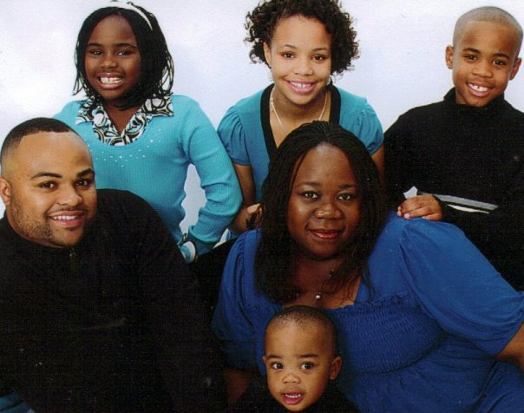

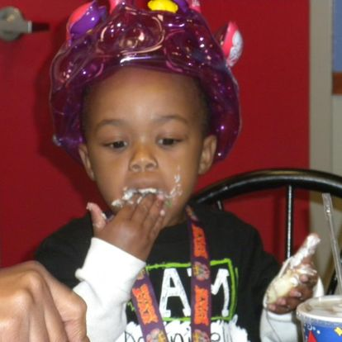

## **Change your mind**



After discovering these things, it took me years to fully realize the extent of this knowledge and apply it to similar situations in my life. This, in turn. has come to shape the type of person I am today and the way I view the world; my relationships with my relatives and close friends and my general outlook on life. I came to love understanding people even if they don’t always understand me... Because of this new state of mind that I have come to acquire over the years, I no longer search for fulfillment in the future or ruminating too much on the past, I try to relish what is and being grateful for those who are considerate and understanding of this me who I am today. Doing this has been a wonderful remedy for the effects of self-loathing and low self-esteem. By putting this into practice it has become easier for me to find a stronger sense of peace, self-worth and overall happiness. I still have times of despair, but in comparison to three years ago I can say these newly adopted habits can mend the soul. If I had known then what I know now, I can definitely say that I would’ve invested more time in those specific relationships even if it was hard. However, now I can only hope to move forward with what I have from and from where I am at now; embracing the uncertain, loving the process, and being thankful for those who have helped me along the way. Always embracing risk while still being cautious of my actions. From when the faithful sun rises to the anticipated rest of each nightfall.