Justin Richerson

Dr. Despain

Transdisciplinary Comm-CODES 121

11 September 2024

Digital Project #1: Shape of Me

In our lives, we have memories that stick to our minds for a very long time, like a memory that shape who we are and who we will become in the future. This is especially true when we are children and adolescents. We tend to have very vivid and formative moments and memories, either good or traumatizing, from birth to when we blow out our 18th Birthday Candle, but it’s not so much those two, pinnacle moments, our most formative memories and experiences happen within the in-between moments, and these moments can make and transform who we are, for better or for worse. I myself have had quite a few of these formative moments, and I am capturing this memory and immortalizing it within this essay.

One thing that has shaped me into who I am today was when I was in third grade. Back then, I had gone to a private school, and one of the things we did there was Accelerated Reading Goals, or AR Goals, where we had to read a certain number of books in order to meet a certain goal, it was essentially a way for us to be incentivized by reading a large number of books in a short period. I often neglected these goals as I didn’t like reading a lot as a kid and although I usually wanted the toys given to those who completed their AR goals at that specific point, I always justified it by just thinking I could get the same thing, just with less reading. Near the end of the school year, we had a party for those who had met their AR Goal. I was at the precipice of the 100% required, I was invited to the party, and the teacher had a whole stack of short books I could read while the party occurred, and I could join when I reached the goal. When I finished reading the book, I had to take an online test to test my knowledge of those books. My classmates gathered around me as I took it, and when I scored 100%, my whole class cheered for me. For the first time in my life, I was the center of attention, I was the winner.

When I experienced that, it was a sharp contrast to the reaction I was expecting, especially with the amount of apathy and self-doubt I had within myself. Back then, I was terrified of failure and disappointment. Just the year before, I was a second grader and the new kid at school. When progress reports came out, I received an F in Math, and even though some might say that this wasn’t that serious, that single letter grade has been burned into my mind’s eye. This completely changed the way I saw letter grades, instead of a way to help me develop, I began to see it as an absolute desertion of my intelligence and even my worth as a human being. While I was still at that school, I learned to hide all my assignments when I received bad grades. I had hidden them in my backpack, under my desk, within my many binders and folders to hide them from my sight, and especially my mother, who had first scrutinized me for the F on my progress report. Lying had eventually become second nature to me, when no one was looking, I had disposed of my low-graded assignments, my shame, my failures. I made sure to keep them away from any judgmental eyes. This then evolved into a sharp need to always succeed in everything I set out to do. Whenever I had a quiz, I would need to be at least the few best performing so I could feel a shred of validation for myself, from my peers, and especially my parents. I thrived off compliments and positive validation of my talents and skills. It became the one thing I started to work for.

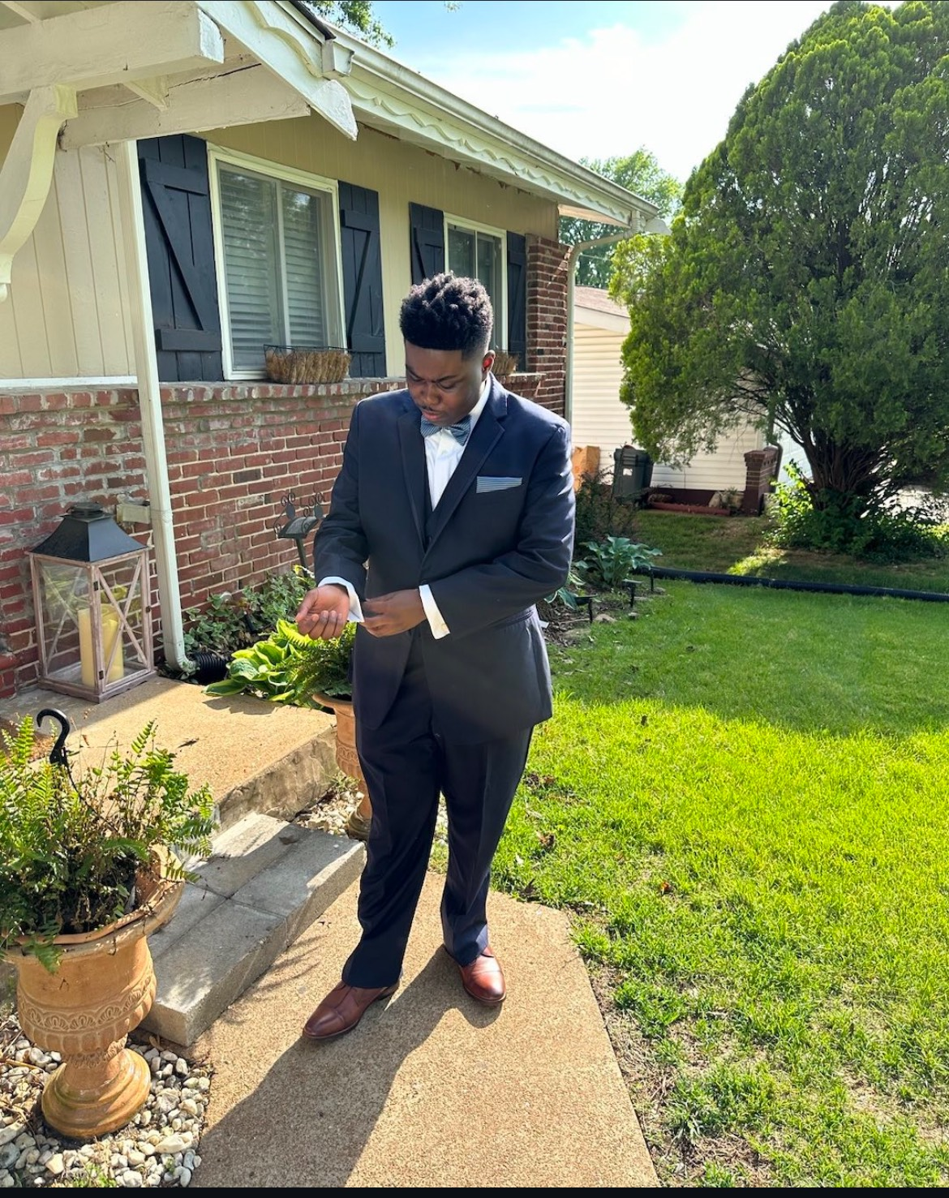

Over my transfer to middle school, I was uprooted from familiar environment once again and thrust into a new one. This time, this was public school as we had moved from where I had spent all my childhood when I was around 11. Grades 6th – 8th were very much formative for me, unfortunately, those transformations were not always positive. I thankfully gave up lying about the assignments, but I had to battle a much darker problem that haunts me to this day: Isolation. Most of the friendships from the people at this new school were friendships that had been flourishing ever since they were in elementary school and even kindergarten, so making friends wasn’t really on the table for me, and on top of that, I had suffered from my first real taste of bullying shortly after the first few weeks, such as brushing me off, playing cruel pranks, or insulting me behind my back, or to my face. This had caused me to wish to retreat to quiet places where I would be all alone, with no prying eyes on me, no one to judge me for my appearance or intentionally ruin my joy and peace for their amusement. I became relatively introverted, and I became very withdrawn from everyone, I only came to school and went right back home. Over time this had become second nature to me, I was desensitized to the world around me, but then, during the midpart of my 8th-grade semester, something happened…

COVID-19 was very much a disease fresh from the underworld; the people who denied it inevitably were infected with it, but in the weirdest way, I was relieved. I was relieved because there would be no one to bully me, and no difficult decisions, the world had gone completely silent, and for the first time in a while, I was truly happy.

When high school rolled around, fresh out of COVID-19, it was once again very formative for me, but in a much more positive way. I had just come back from virtual school during my freshman year of high school where academically, I was in a terrible place, and I was determined to change that in High School, the one point where grades started to matter, my sophomore year was the most positive for me, It’s when I discovered my love for science, specifically biology, I also developed a love for mythology and writing, when class was over for lunch, I would often go to the library and write funny little short stories to pass the time, its no wonder that I became an introvert to the highest degree, I still didn’t have any friends, but that was fine for me, because I was, for the most part, content with being alone.

Then came graduation, the culmination of all my efforts within my 12 years of schooling, I felt as though I achieved something, I walked across that stage the victor over the long years, surrounded by all those who supported me through those years. That was the day that made me who I am today: A winner.

