Kai Denham

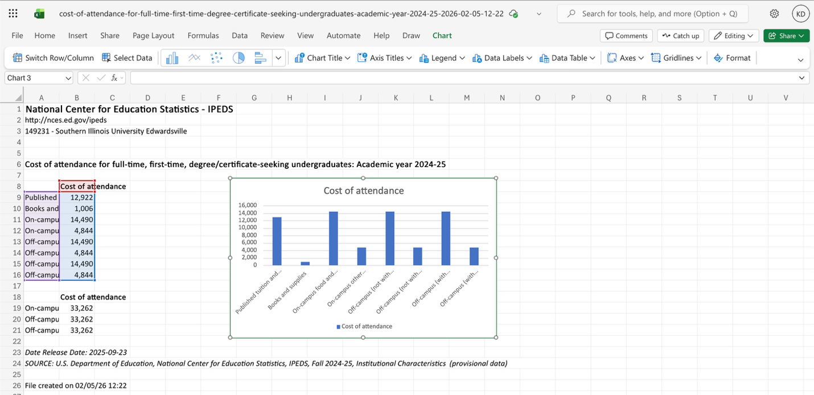
Students that’s going to SIUE are credited for making the data because they had probably got their data from a survey that was done around the campus. They created this to show how much students take over their expenses once they are in college. Not having their parents pay for their expenses while they are at school. Seeing the data can tell who helps their parents with taking over their expenses or even just rely on their parents for things while they are in college. The data is organized by the different college expenses that students in college need ocampus and off campus. The categories that the data set provides is published tuition and required fees, books and supplies, on-campus food and housing, on campus other expenses, off-campus (not with family) food and housing, off-campus (not with family) other expenses, off-campus (with family) food and housing, and off-campus (with family) other expenses). They break it down like this because some students may live on campus or some might live off campus not with their family or it is even some that live off campus with their family. Having these breakdowns can help tell people what students might do while being at school and how they use their expenses. No, the creator did not describe their cleaning process of the data set. Their effect might have on the data is the order that they put the categories in for the different expenses. The creators’ identities and goals must shape the data by making sure they have all the right numbers that they need for the data set to make it look nice a well and put together. I would use this data set for comparing what college expenses does different students use while they are at school rather if it means for them living on campus or even if it means that are off campus without their family or even living off campus but with their families.

