**Name_____________**  **Scientist Spotlight: Dr. Nina Jablonski**

Please read this document carefully before you start! Your homework submission should be *at least* 250 words total, addressing the questions at the bottom of the page.

**Scientist Spotlight: Dr. Nina Jablonski**

Dr. Nina Jablonski is an anthropologist and paleo-biologist that studies human evolution at Penn State University. She was born and raised on a farm in upstate New York, where she developed a passion for digging up fossils in a nearby creek. As a child she spent a lot of time watching National Geographic, which cultivated an interest in human evolution and led her to pursue a biology degree at Bryn Mawr College. Despite earning a degree in molecular biology and having pressure to attend medical school from her parents, Dr. Jablonski developed a passion for evolution and anthropology and chose to pursue a PhD in biological anthropology at the University of Washington.

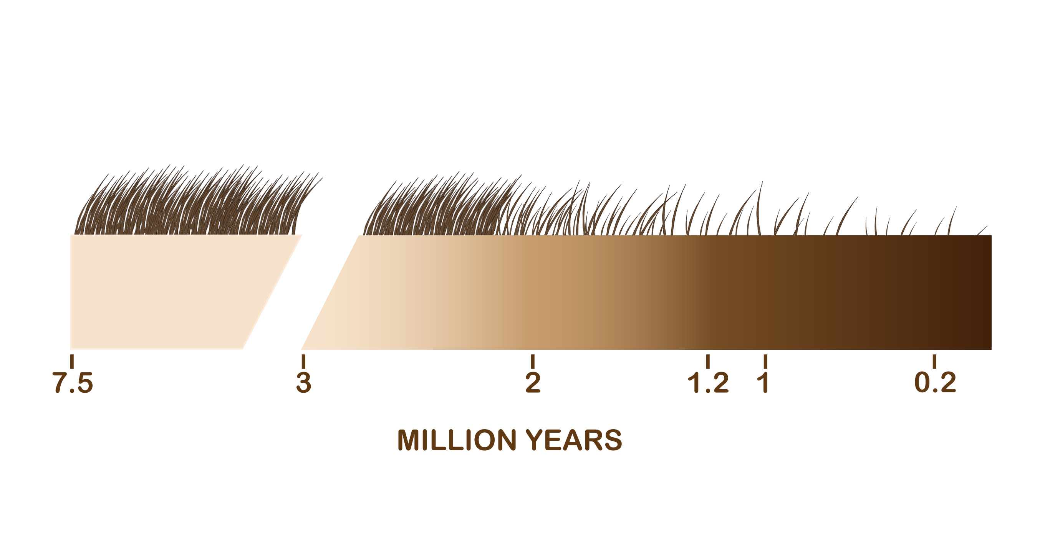Dr. Jalonski research focuses on the evolution of primates and humans. One of her major research areas includes the evolution of human skin, pigmentation, and hair. Her research describes how skin color and hair can play a role in human self-identities, and the major role that these evolutionary processes play in history and society.

1. To learn more about the evolution of skin color, watch the following talk: [Nina Jablonski: Skin color is an illusion | TED Talk](https://www.ted.com/talks/nina_jablonski_skin_color_is_an_illusion/transcript?language=en#t-859407)
2. Browse through this journal article to appreciate the science of studying human skin color and race: [Skin color and race - Jablonski - - American Journal of Physical Anthropology - Wiley Online Library](https://onlinelibrary.wiley.com/doi/10.1002/ajpa.24200)

**Instructions for Written Assignment:**

After reviewing these resources, write a 250 word or more reflection with your responses TO BE SUBMITTED TO Blackboard, which addresses ideas related to the following questions:

1. ***What was most interesting to you in reviewing these resources?***
2. ***What did you learn from these resources about the evolution of skin color?***
3. ***What do these resources tell you about the types of people that do science?***
4. ***What new questions do you have after learning about Dr. Jablonski’s research and how human skin color evolved?***