What Really Makes Me, Me
My name is Nadia Harris, something that represents me is my family and friends. My family represents me because without them I am nothing. Without my family by my side every step of the way, I wouldn’t be who I am today. My family are my biggest supporters in all my achievements, no matter how big or small. They are always on the “sidelines” cheering me on. I am a physical representation of my family. My family consists of both my mom and dad along with my 3 sisters. 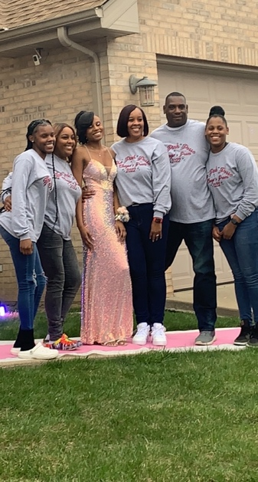Growing up in school, I’ve always heard the phrase that “You are a representation of your parents”, and that has always stuck with me because the way a child acts is visual representation of the parents’ teachings and influences. My parents instilled values in me that I live by day-to-day which include honesty, respect, and work ethic. The values instilled by parents shape an individual. I live by respect because I was always told that “you treat others how you want to be treated,” and plus you should always be respectful to others. I live by honesty because why life? Also, just like “The Boy Who Cried Wolf,” you have only so many times to lie and people believe before everything you say goes completely out the window. I especially live by work-ethic because without putting the work nothing will ever get done. Also, for me for achieve every single one of my goals I must be willing to put the work in. Times that I can most certainly remember my family cheering me on from the sidelines would be graduations, senior night/awards, scholarship acceptances. For my kindergarten graduation, both my parents came even though my material grandmother had just passed away a couple weeks to a month prior and my mother was grieving heavily. Both of my parents have always shown up to my graduation no matter the circumstances, for example my 8th grade graduation was during covid and even though I was still able to walk across the stage to get my diploma, my parents had to sit outside in the car and watch me walk virtually. For my track and field senior night both my mom and dad, and older sister came to support me even though it was raining and cold that day. Although by the time the final event came which I had to run, even though my mom and older sister had left for a meeting they had to attend, my dad was still there to see me bring the win home for my team on our turf. At my scholarship banquets my mom usually comes with me being that the dates and times fall on days that my dad must work, but the scholarship banquets are a huge deal to my mom because 1. I was chosen to receive the scholarship out of all the applications and 2. because these scholarships are helping me continue furthering my education. 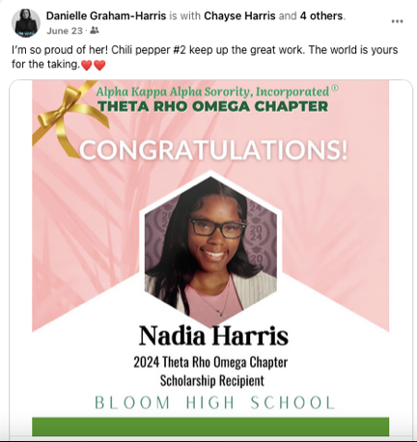But to really sum up why my family represents me is because they are my biggest rocks, and I must continue to work hard to make them proud. My friends represent me because they basically shape my personality in a sense. My friends bring out the best in me. My friends know that I am a very shy person. The necessarily bring that shyness out of me each time we get around each other. I have a friend group back at home where we’ve all been friends since 6th/7th grade, the group originally started with our choir’s six flags trip but as the years have continued to pass, we have just kept getting closer and closer. Even though we are all currently going to different schools in different states, we remain close to this day. The first person that I remember meeting in the group was Adonis, because he lives across the street from me; he also happens to be my cousin; we met way before the group was formed and way before we all knew each other. This friend group consists of my best friend India, my cousin Adonis, my friend who also attends SIUE Deanna, Isabel, Jordan, Kentasia, Daron, Quentin, Jabari, and Darius. 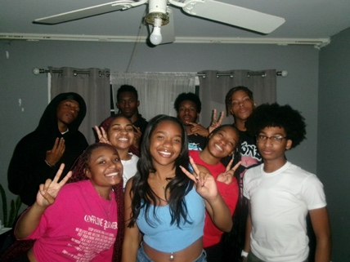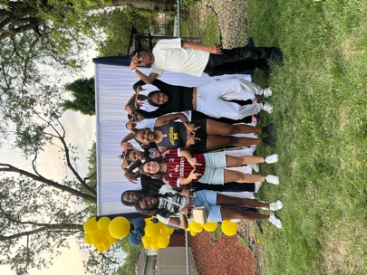Since I’ve been here at SIUE, I’ve slowly started making more friends; even though I don’t really like talking to people. The people that I really hang out with here are my friend Deanna from back home and her roommate/suitemates. I’ve formed a strong relationship with Deanna’s roommate and suitemates-Relle, Loreal, and Alani- being that I am with them 80% of the time outside of classes and being that Alani, Loreal, and I are all nursing majors. I first started hanging out with Loreal and Alani because I would go down to Deanna’s room and just be hanging in there with her, and Loreal and Alani would always be in their room when I went down there. It started off as simple greetings every time I was down there but soon became a friendship, plus we all had a class together. Although Alani, Loreal, Relle, and I haven’t really known each other that long, they are cool people, but Loreal and I act just alike; we are basically kind of the same person just in different fonts.

