Troy Shaffer

Dr. DeSpain

CODES121

15 September 2023

Growing Up Gay

“Rise and shine, get up and get ready for church boys”, is what I heard every Sunday growing up. My mom is a religious woman who brought us to church every Sunday she could. I did not hate church when I was a kid. All of the kids who were fifth grade and under got sent to a playroom that was upstairs. We sang a few Jesus songs and talked about a short story from the bible and then proceeded to play games for the rest of the time. It was fun for me, I enjoyed playing dodgeball at church every sunday. But then I got to sixth grade, and I had to sit with my family where they preached real Jesus stuff. I hated every second of it, I did not care, I do not believe in God, I was only there to make my mom happy. 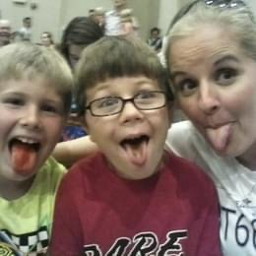

It was fourth grade when I first realized something was up, that I was not like the other boys. I was uncomfortable around other boys my age and loved talking with girls. I did not know what it meant, I was nine years old. There was a feeling in my body that I could not explain. Once I hit middle school is when things started to make sense. This is when the realization of me being gay started but I wanted to think I was bisexual. I hated this part of myself, due to the fact that my entire family is not supportive of it. This led to me feeling the need to hide my true self to the world. There was a lot of confusion, frustration, and mental strain. Lots of nights were spent crying myself to sleep. I could not even escape at school because my brother was there too, and the thought of him finding out through someone else was terrifying. One day in the middle of eighth grade, a rumor started about my sexuality and it felt like my world was collapsing around me. People I knew gave me mean glares in the hallways and my own friends questioned it. One of my best friends came up to me in class and said “Troy, I have a question. People are saying you are gay, is that true? It's totally okay if you are.” My entire body froze and filled with panic. I quickly responded with No, and said it was just a rumor. He said “Thank god”. That day has stuck with me for years and ever since I have been very cautious with who I let be close to me.

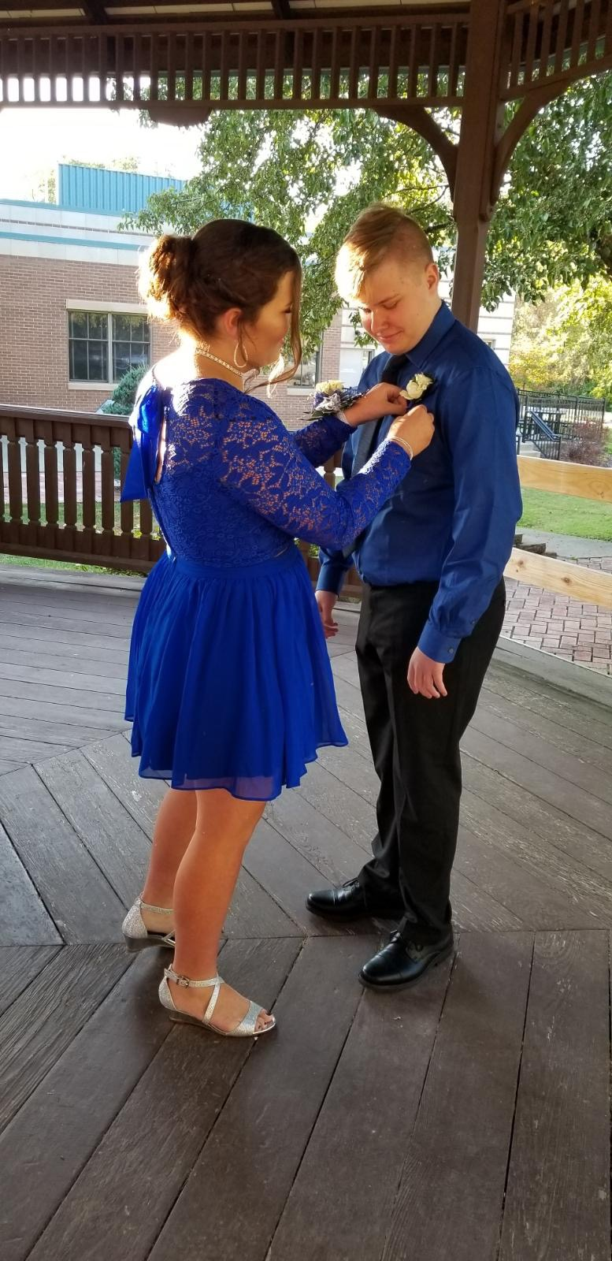 High school started and I felt much more of a preference to boys than girls and this was the start of extreme self hatred. Freshman year I met a girl and we very quickly became great friends and would talk to each other every day. There was a lot of confusion with her, we were best friends, and I thought I wanted more. Freshman homecoming came around and I wanted to go with her. I popped the big question and asked her to be my date to which she said yes. This homecoming was a very big turning point in discovering myself. The dance was awful and awkward. We were both uncomfortable and left very early. After leaving, we went to her house and I realized this was not what I wanted and our friendship would never be the same again. Months passed and we stopped talking nearly as much and there was just an awkward tension between us. This slowly led to the end of our friendship altogether.

 The school year started off normal, but quarantine hit and everyone was locked in their houses. This was a period of a lot of self discovery for me. Like my love for Taylor Swift when she released my favorite album of all time *folklore*. This album has been the soundtrack to my life ever since. I felt such a deep connection to the songs especially a track titled “my tears ricochet”. This song got me through a lot of dark thoughts about the fact of my parents possibly not accepting me for who I was. Not only did I discover my love for this album, around this time I started to accept the fact that I was not bisexual and was just gay. The hatred of this part of me was starting to slowly dwindle. I was very much still very uncomfortable with it and was not ready for people to know. However, keeping it inside proved to be very difficult and I just needed to talk to someone about it. Sophomore year was when I came out for the first time, I told my close friend of several years Livia. This felt like a thousand tons off of my shoulders, she was so supportive and it meant the world to me. It would not be until senior year until I was more comfortable with it at school. My brother was no longer in school so I had no worry of it getting to him and the rest of my family.

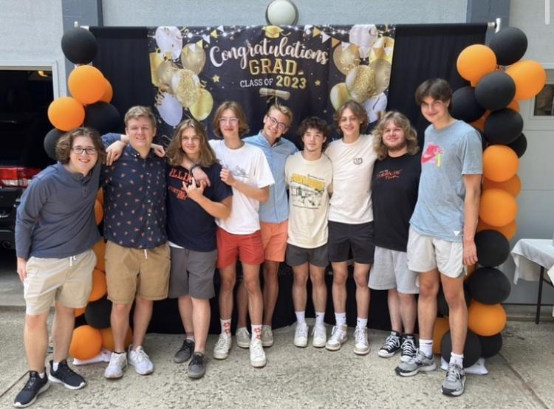 With being more comfortable with my sexuality I wanted to tell all of my friends the truth. This was both easy and difficult. I had two very different friend groups, one being mainly girls and other gay people and the other being all straight guys. The girls and gays group was very natural feeling, I did not feel any pressure coming out to them and knew there would be zero judgement. Gradually, I came out to them, and a majority of them already thought so. The only thing I felt after telling them was utter love and support. However, coming out to “the boys” was much more of a challenge to me. Having the fear of them not liking the fact that I am gay was horrifying. I was afraid that they would think it was weird and I would make them uncomfortable. I came out to one of them way before the others, Owen was the one I was closest to and most comfortable with. He was very supportive and already suspected it. After some time, I finally felt the need to tell the rest of them. So one day, I bit the bullet and finally sent a text to the group chat coming out. This was very anxiety inducing since I was not sure if everyone would be like Owen. I had to turn off my phone and take a step back. A few hours later, I turned my phone back on and was met with so much love. I guess I was not very good at hiding it as much as I thought I was, as once again they all basically knew. To be fair, not many straight guys are obsessed with Taylor Swift.

 Although there were a lot of rough patches, I am more comfortable with myself than I have ever been. This journey is far from over as I am still not out to my family. But with the friends that I have, it has made the process easier and more comforting. Through my experience with church, school, and friends, I have found my true self and I am happy with it.

Picture Citation

Pride Flag:

<https://outrightinternational.org/insights/flags-lgbtiq-community>

All other photos were mine