Argument – Tower Groves community development corporation helps rebuild a better community.
Ritz Park

Ritz Park, originally called South Grand Pocket Park is a great example of community development on South Grand Boulevard. Built in the spring of 2014, the park's creation was with the South Grand Improvement District. A collaborative effort to enhance the overall ambiance and feel of the area. It was built where the iconic Ritz Theatre once was and this connection to the past is obviously commemorated in the park’s name. The Ritz Theatre was built in 1910 and after it was torn down, the plot of land was a rundown parking lot for years. The transformation into a park just brings life to the area, creating a positive environment for visitors to relax. The park has a nice range of hours and is open from 6am to 10 pm.
Ritz Park is more than just a green space with a lot of benches for people to relax, it hosts several different events as well. At the park you can stumble across concerts, markets, festivals, and sometimes even movie showings. People attending these events hosted at Ritz Park brings money to the area and positively affects the economy because they will be around and possibly shop at local businesses.
Overall, Ritz Park's transformation from a grown over parking lot to a fun communal park that also pays homage to the area's history shows the impact that community development can have on a neighborhood. With the park’s ability to host communal events, it not only adds life to the area but also money.

Found Vintage

Found Vintage, located at 3232 South Grand, is another great example of community development in Tower Grove. Formerly an abandoned building on South Grand, this colorful boutique and vintage thrift store, adds much needed character to the area. The modern reuse of an abandoned building enhances the aesthetic appeal but also helps economic wellbeing of the area. Found Vintage has a unique and fun selection of vintage items that attracts both locals and visitors. Found Vintage can serve as a catalyst for even more development in the Tower Grove area, because of the store’s success, it will attract more entrepreneurs and customers to Tower Grove. This also positively impacts nearby businesses and contributes to the overall wellbeing of the area.
Found Vintage also has a commitment to more sustainable practices, as it is a thrift store, but this aligns with more modern values and will resonate with environmentally conscious customers. This gives Found Vintage a more responsible look and shows that it is a socially aware contributor to the community. I think the fact that a once abandoned building being repurposed into a lively thrift store reflects these more sustainable practices and values.
In conclusion, Found Vintage may just be a thrift store, but it is also full of positive change in Tower Grove. The thrift store brings character to Tower Grove with a very unique selection of reused and repurposed clothes. The transformation of an abandoned building into a thriving thrift store shows the potential for positive change when community members invest time and money in their area.

Umbrella Shop - 3127 S. Grand Blvd. St. Louis, MO 63118

An umbrella shop is coming to South Grand and taking the place of a closed down pawn shop that has been closed for over 9 years. The original Pawn Shop closed after the protests over the murder of Michael Brown in Ferguson Missouri. But people are excited for the empty building to finally be filled with something, even if it is an Umbrella Store.
Before it was a shutdown pawn shop, the building was a Kroger’s grocery store, and before it was a grocery store it was an Umbrella Store. The owner of the space, Troy Howard, wanted to recreate the old umbrella store but with a twist. He is keeping the name, “The Umbrella Shop”, but the store today has more going on. More than just an umbrella shop, it is going to be a “community event space” with visual arts, live music, and “circus arts”. The store plans to let artists sell their art and get 100% of the money for it. Howard says that he does not believe in Exploiting artists. He believes that this will lead to more community, and art galleries that take money from the artists are not a “community effort.”
The Umbrella Shop is a great example of community development on South Grand. It is taking an old, closed pawn shop and giving it a great repurpose. The Umbrella Shop will not only add character to the area but also entertainment. With it being more than just an Umbrella Shop, it will attract many customers, local or not, which will lead to economic growth in the area.
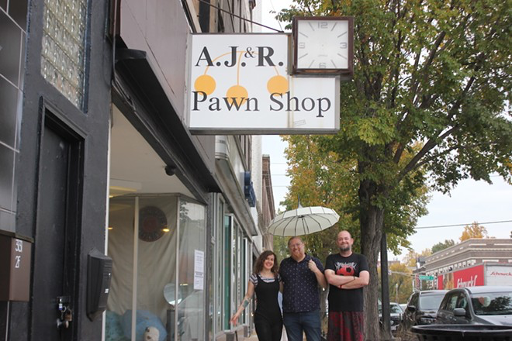

Red Bird Vegan – 3117 S. Grand Blvd

Red Bird Vegan is a brand-new restaurant built on South Grand. The new restaurant made its debut in the Summer of 2023, has quickly grown in popularity due to its plant-based menu, giving itself a niche in the Tower Grove area. The new vegan restaurant is taking the place of what was once an old Jimmy John’s. The restaurant's commitment to veganism is very clear in its menu, plant-based burgers, and vegan twists on classic comfort foods. With the restaurant being vegan, it will attract a lot of vegans and vegetarians of the area, as well as people who eat meat who just want to try something new. Red Bird Vegan will be a great addition to St. Louis’ vegan cuisine, with its name being symbolic of St. Louis and its baseball team, the Cardinals.
Red Bird Vegan actively works with local farmers and suppliers to source its ingredients. Doing this, not only supports nearby businesses and the community, but also aligns with South Grand’s commitment to sustainability. Red Bird Vegan will get customers from nearby and far to try it’s all vegan menu, which will only help the nearby businesses and Tower Grove area.
Red Bird Vegan's all new vegan menu and warm ambiance adds much needed character to South Grand. The new restaurant will attract both Tower Grove residents and visitors alike. The restaurant also being open from 6am to 9pm seven days a week will rival other restaurants as a healthier option. Red Bird Vegan is an example of community development and how new businesses can help liven up an area, even if it has a more targeted audience.

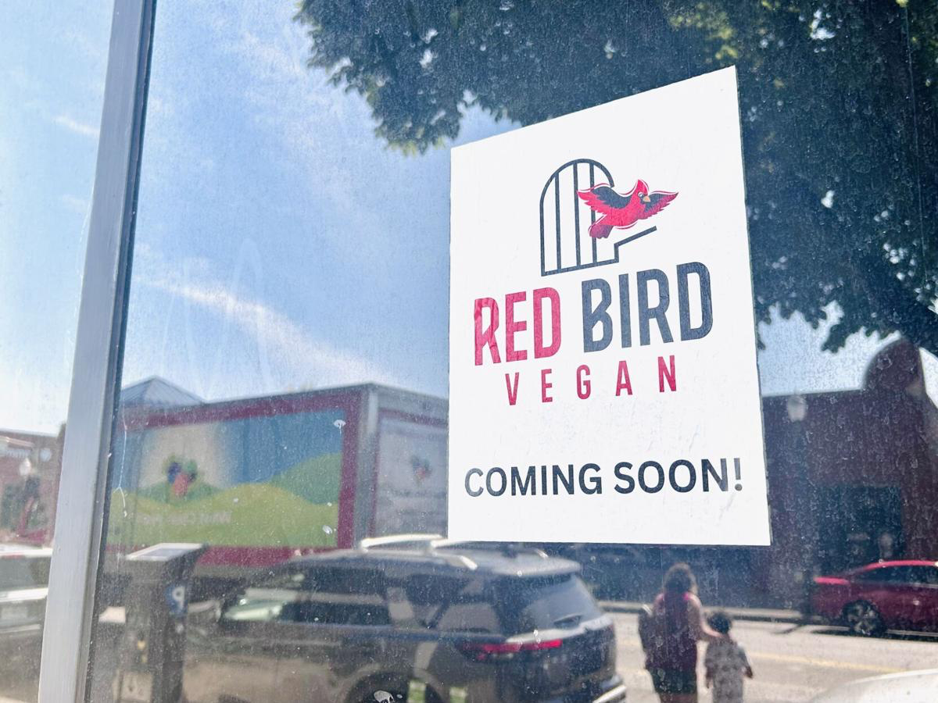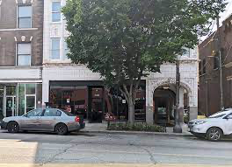

Whichever picture you think that would look better for the slides

